**SECTION A-46 MARKS**

**Attempt** all **questions in this section.**

1. **Complete the following equations and write the IUPAC names of the main organic product in each case. (@01½ marks)**



1. **State the conditions and write equation for the reaction between nitric acid and;**
2. **Sulphur. (02 marks)**

**………………………………………………………………………………………………………………………………………………………………………………………………………………………………………………………………………………………………………………………………………………………………………………………………………………………………………………………………………..**

1. **Tin. (02½ marks)**

**………………………………………………………………………………………………………………………………………………………………………………………………………………………………………………………………………………………………………………………………………………………………………………………………………………………………………………………………………..**

1. **The enthalpies of some reactions are given below**.



1. **Calculate the lattice energy of sodium (3 marks)**

**…………………………………………………………………………………………………………………………………………………………………………………………………………………………………………………………………………………………………………………………………………………………………………………………………………………………………………………………………………………………….**

1. **(i) From your answer in (a); state whether sodium hydride is a stable compound or not. (0½ mark)**

**………………………………………………………………………………………………………………………………………………………………………………………………………………………………………………**

**(ii) Give a reason for you answer in b (i). (1 mark)**

**……………………………………………………………………………………………………………………………………………………………………………………………………………………………………………**

1. **The electrode potentials of S2O82-(aq)/SO42-(aq) and I2(aq)/I(aq) are +2.01V and +0.54V respectively.**
2. **Write the:**
3. **Cell notation of the cell formed when the half cells are combined. (1 mark)**

**…………………………………………………………………………………………………………………………………………………………………………………………………………………………………………………………**

1. **Overall cell reaction. (01½ marks)**

**……………………………………………………………………………………………………………………………………………………………………………………………………………………………………………………….**

**(b)(i).** **Calculate Gibbs free energy for the cell in (a).**

**[Faraday’s constant = 95,600c] (02 marks)**

**………………………………………………………………………………………………………………………………………………………………………………………………………………………………………………………………………………………………………………………………………………………………………………………………………………………………………………………………………………………………………………….**

**(ii).** **State whether the cell reaction is feasible or not. Give a reason for your answer.**  **(01 mark)**

**…………………………………………………………………………………………………………………………………………………………………………………………………………………………………………………………**

1. **State what would be observed and wrote equation for the reaction that takes place when:**
2. **Benzene is warmed with a mixture of concentrated nitric acid and concentrated sulphuric acid (02 marks)**

**………………………………………………………………………………………………………………………………………………………………………………………………………………………………………………………………………………………………………………………………………………………………………………………………………………………………………………………………………………………………………………….**

1. **Dilute sulphuric acid was added to copper (I) oxide. (02½ marks)**

**……………………………………………………………………………………………………………………………………………………………………………………………………………………………………………………………………………………………………………………………………………………………………………………………………………………………………………………………………………………………………………………**

1. **Aluminium powder was added to aqueous solution of iron (III) chloride. (02 marks)**

**……………………………………………………………………………………………………………………………………………………………………………………………………………………………………………………………………………………………………………………………………………………………………………………………………………………………………………………………………………………………………………………**

1. **Perspex is a polymer of structure:**



1. **Name the reaction leading to the formation of Perspex. (0½ mark)**

**…………………………………………………………………………………………………………………………………………………………………………………………………………………………………………….**

1. **Write the structure and give the IUPAC name of the monomer used to manufacture Perspex**. **(02 marks)**

**…………………………………………………………………………………………………………………………………………………………………………………………………………………………………………….**

1. **A solution containing 5.5g of Perspex in 1dm3 of benzene has an osmotic pressure of 6.796 x 10-2 atmospheres at 25oc.Calculate the:**
2. **Molecular mass of Perspex. (02 marks)**

**………………………………………………………………………………………………………………………………………………………………………………………………………………………………………………………………………………………………………………………………………………………………………………………………………………………………………………………………………………………………………………………………………………………………………………………….**

1. **Value of n. (01 mark)**

**……………………………………………………………………………………………………………………………………………………………………………………………………………………………………………………………………………………………………………………………………………………………………………………………………………………………………………………………………...**

1. **State one application of Perspex. (0½ mark)**

**………………………………………………………………………………………………………………………………………………………………………………………………………………………………...**

1. **The melting points of some of the chlorides of group II elements of the periodic table are given in the table below.**

|  |  |  |  |  |
| --- | --- | --- | --- | --- |
| **Chloride** | **MgCl2** | **CaCl2** | **SrCl2** | **BaCl2** |
| **Melting point(ᵒC)** | **708** | **772** | **878** | **967** |

1. **State how the melting points vary. (01 mark)**

**………………………………………………………………………………………………………………………………………………………………………………………………………………………………………………**

1. **Explain your answer in (a). (03 marks)**

**……………………………………………………………………………………………………………….**

**………………………………………………………………………………………………………………………………………………………………………………………………………………………………………………………………………………………………………………………………………………………………………………………………………………………………………………………………………………………………………………………………………………………………………………………………………………………………………………………………………………………………………………………………………………………………………………………………………………………………………………………………………………………………………………………………………………………………………………………………**

1. **Write equation to show how the following conversions can be effected.**
2. **Propan-1-ol from propyne. (03 marks)**

**…………………………………………………………………………………………………………………………………………………………………………………………………………………………………………………………………………………………………………………………………………………………………………………………………………………………………………………………………………………………………………………………………………………………………………………………………………………………………………………………………………………………………………………………………………….**

1. **Bromocyclohexane from hydroxybenzene. (02½ marks)**

**…………………………………………………………………………………………………………………………………………………………………………………………………………………………………………………………………………………………………………………………………………………………………………………………………………………………………………………………………………………………………………………………………………………………………………………………………………………………………………………………………………………………………………………………………………………………………………….**

1. **The conductivity of a 0.0634 moldm-3 solution of 2-hydioxy propanoic acid was found to be 1.138 x 10-3 Scm-1 and the molar conductivity at infinite dilution at 25oc is 388.5 5cm3mol-1. Calculate:**
2. **pH of the solution. (02 marks)**

**…………………………………………………………………………………………………………………………………………………………………………………………………………………………………………………………………………………………………………………………………………………………………………………………………………………………………………………………………………………………………………………..**

1. **acid dissociation constant, Ka at 25oc. (02½ marks)**

**…………………………………………………………………………………………………………………………………………………………………………………………………………………………………………………………………………………………………………………………………………………………………………………………………………………………………………………………………………………………………………………..**

**SECTION B-54 MARKS**

**Attempt** ANy **six questions in this section.**

1. **An organic compound, R contains 58.8% carbon, 9.8% hydrogen and the rest oxygen.**

**(a) Calculate the empirical formula of R. (02½ marks)**

**…………………………………………………………………………………………………………….**

**…………………………………………………………………………………………………………….**

**…………………………………………………………………………………………………………….**

**…………………………………………………………………………………………………………….**

**…………………………………………………………………………………………………………….**

1. **Determine the molecular formula of R.[RFM of R = 102] (01½ marks)**

**………………………………………………………………………………………………………………………………………………………………………………………………………………………………………………………………………………………………………………………………………………………………………………………………………………………………………………………………………………………………………………………………………………………………………………………………………………………………………………………………………………………………………………**

1. **R reacts with aqueous sodium hydroxide under reflux to produce propan-1-ol as one of the products.**
2. **Identify R. (01 mark)**

**………………………………………………………………………………………………………………………………………………………………………………………………………………………………**

1. **Write an equation to show how R can be synthesized from propan-1-ol and indicate a mechanism for the reaction. (04 marks)**

**…………………………………………………………………………………………………………………………………………………………………………………………………………………………………………………………………………………………………………………………………………………………………………………………………………………………………………………………….**

**………………………………………………………………………………………………………………………………………………………………………………………………………………………………**

1. **Sulphur dioxide and oxygen react to form sulphur trioxide according to the equation**: 
2. **(i).Write the expression for the equilibrium constant, Kp for the reaction. (01 mark)**

**…………………………………………………………………………………………………………………………………………………………………………………………………………………………………………**

**(ii).When 3 moles of sulphur dioxide were made to react 2 moles of oxygen at 450oc in a 1dm3 vessel, the equilibrium mixture was found to contain 20% sulphur dioxide at 50atm. Calculate the equilibrium constant Kp for the reaction. (04 marks)**

**………………………………………………………………………………………………………………………………………………………………………………………………………………………………………………………………………………………………………………………………………………………………………………………………………………………………………………………………………………………………………………………………………………………………………………………………………………………………………………………………………………………………………………………………**

1. **State giving reasons, how the concentration of sulphur trioxide at equilibrium would be affected when:**
2. **Pressure is increased. (01½ marks)**

**…………………………………………………………………………………………………………………………………………………………………………………………………………………………………………**

**…………………………………………………………………………………………………………………………………………………………………………………………………………………………………………**

1. **Temperature is increased. (01 mark)**

**………………………………………………………………………………………………………………………………………………………………………………………………………………………………………..**

**…………………………………………………………………………………………………………………………………………………………………………………………………………………………………………**

1. **Helium is added at constant pressure. (01½ marks)**

**………………………………………………………………………………………………………………………………………………………………………………………………………………………………………..**

**………………………………………………………………………………………………………………………………………………………………………………………………………………………………………**

1. **(a)(i). Write the general electronic configuration of group IV elements of the periodic table. (01 mark)**

**……………………………………………………………………………………………………………………………………………………………………………………………………………………………………………………**

**(ii).State the common oxidation states exhibited by group IV elements. (01 mark)**

**………………………………………………………………………………………………………………………………………………………………………………………………………………………………………………………**

1. **(i)Give three properties in which carbon shows a different behavior from other group IV elements**.  **(03 marks)**

**………………………………………………………………………………………………………………………………………………………………………………………………………………………………………………………………………………………………………………………………………………………………………………………………………………………………………………………………………………………………………………………………………………………………………………………………………………………………………………..**

**(ii)Explain your answer in b (i). (01½ marks)**

**……………………………………………………………………………………………………………………………………………………………………………………………………………………………………………………………………………………………………………………………………………………………………………………………………………………………………………………………………………………………………………………………………………………………………………………………………………………………………………………………………………………………………………………………………………………………………………..**

1. **Lead (IV) oxide was added to aqueous manganese (II) nitrate followed by concentrated nitric acid and the mixture heated.**
2. **State what was observed. (01 mark)**

**……………………………………………………………………………………………………………………………………………………………………………………………………………………………………**

1. **Write equation for the reaction that took place. (01½ marks)**

**………………………………………………………………………………………………………………………………………………………………………………………………………………………………**

1. **The data showing the pH changes during the titration of 0.1Moldm-3 solution of sodium hydroxide against 10cm3 of aqueous ethanoic acid is given in the table below.**

|  |  |  |  |  |  |  |  |
| --- | --- | --- | --- | --- | --- | --- | --- |
| **Volume of NaOH (cm3)** | **0.0** | **2.0** | **4.0** | **6.0** | **8.0** | **10.0** | **14.0** |
| **pH** | **2.9** | **4.3** | **4.7** | **5.2** | **6.4** | **12.0** | **12.4** |

1. **Plot a graph of pH against the volume of sodium hydroxide.**

**(03 marks)**



1. **Use your graph to determine the pH at equivalence point and volume of sodium hydroxide used to neutralize the acid.**
2. **pH at equivalence point. (01 mark)**
3. **Volume of sodium hydroxide used to neutralize the acid. (01 mark)**

**………………………………………………………………………………………………………………………………………………………………………………………………………………………………………………………………………………………………………………………………………………………………………………………………………………………………………………………………………………………………**

1. **Calculate the molarity of ethanoic (acetric) acid.(02½ marks)**

**……………………………………………………………………………………………………………………………………………………………………………………………………………………………………………………………………………………………………………………………………………………………………………………………………………………………………………………………………………………………………………………………………………………………………………………………**

1. **The pH range for some indicators are given in the table below**.

|  |  |
| --- | --- |
| **Indicator** | **pH range** |
| **Methyl orange** | **3.2 – 4.4** |
| **Phenolphthalein** | **8.3 – 10.0** |
| **Cresol red** | * 1. **– 8.8** |

**Which of the indicators is suitable for this titration? Give a reason for your answer. (01½ marks)**

**…………………………………………………………………………………………………………………………………………………………………………………………………………………………………………………………………………………………………………………………………………………………………….**

**………………………………………………………………………………………………………………………**

1. **Complete the following equation(s) and write the mechanism(s) for the reaction(s) leading to the formation of major organic products.**



**………………………………………………………………………………………………………………………………………………………………………………………………………………………………………………………………………………………………………………………………………………………………………………………………………………………………………………………………………………………………………………………………………………………………………………………………………………………**



**………………………………………………………………………………………………………………………………………………………………………………………………………………………………………………………………………………………………………………………………………………………………………………………………………………………………………………………………………………………………**

**………………………………………………………………………………………………………………………………………………………………………………………………………………………………………………………………………………………………………………………………………………………………………………………………………………………………………………………………………………………………**

1. **Describe the reactions of group (II) elements with water. (05 marks)**

**……………………………………………………………………………………………………………………………………………………………………………………………………………………………………………………………………………………………………………………………………………………………………………………………………………………………………………………………………………………**

1. **Potassium chromate solution was added to aqueous barium chloride solution followed by dilute nitric acid drop-wise until in excess.**
2. **State what was observed. (01 mark)**

**…………………………………………………………………………………………………………………………………………………………………………………………………………………………………………**

1. **Write equation(s) for the reaction(s) that took place.**

**(03 marks)**

**……………………………………………………………………………………………………………………………………………………………………………………………………………………………………………………………………………………………………………………………………………..**

1. **Compound F, contains 56.4% phosphorus the rest being oxygen. [F = 220]**
2. **(i). Determine the molecular formula of F. (02 marks)**

**……………………………………………………………………………………………………………………….**

**………………………………………………………………………………………………………………………………………………………………………………………………………………………………………………………………………………………………………………………………………………………………………………………………………………………………………………………………………………………………………………………………………………………………………………………………………………………………………………………………………………………………………………………………………………………………**

**(ii).Write equations for the reaction between F and water. (01½ marks)**

**…………………………………………………………………………………………………………………………………………………………………………………………………………………………**

1. **Write equation(s) for the reaction(s) of excess aqueous sodium hydroxide solution with:**
2. **Phosphorus. (01½ marks)**

**……………………………………………………………………………………………………………………………………………………………………………………………………………………………………………………**

1. **Chromium. (01½ marks)**

**……………………………………………………………………………………………………………………………………………………………………………………………………………………………………………………**

1. **Silicon. (01½ marks)**

**……………………………………………………………………………………………………………………………………………………………………………………………………………………………………………………**

1. **Calculate the oxidation state of Bromine in the following ions**.
2. **BrO-3. (01 mark)**

**………………………………………………………………………………………………………………………………………………………………………………………………………………………………………………………………………………………………………………………………………………………………………………………**

1. **BrO-. (01 mark)**

**………………………………………………………………………………………………………………………………………………………………………………………………………………………………………………………………………………………………………………………………………………………………………………………**

1. **State what would be observed and write equation for the reaction that takes place when potassium bromated (V) solution was added to acidified potassium iodide. (02½ marks)**

**Observation (s):**

**…………………………………………………………………………………………………………………………………………………………………………………………………………………………………………………………**

**Equation:**

**……………………………………………………………………………………………………………………………………………………………………………………………………………………………………**

1. **Sodium hydroxide and chlorine are manufactured by electrolysis of brine in a mercury cell**.
2. **Name the anode and cathode respectively**:

**……………………………………………………………………………………………………………………………………………………………………………………………………………………………………**

1. **Write equation(s) for the reactions that take place at:**

**Anode:**

**……………………………………………………………………………………………………………………………………………………………………………………………………………………………………**

**Cathode:**

**……………………………………………………………………………………………………………………………………………………………………………………………………………………………………**

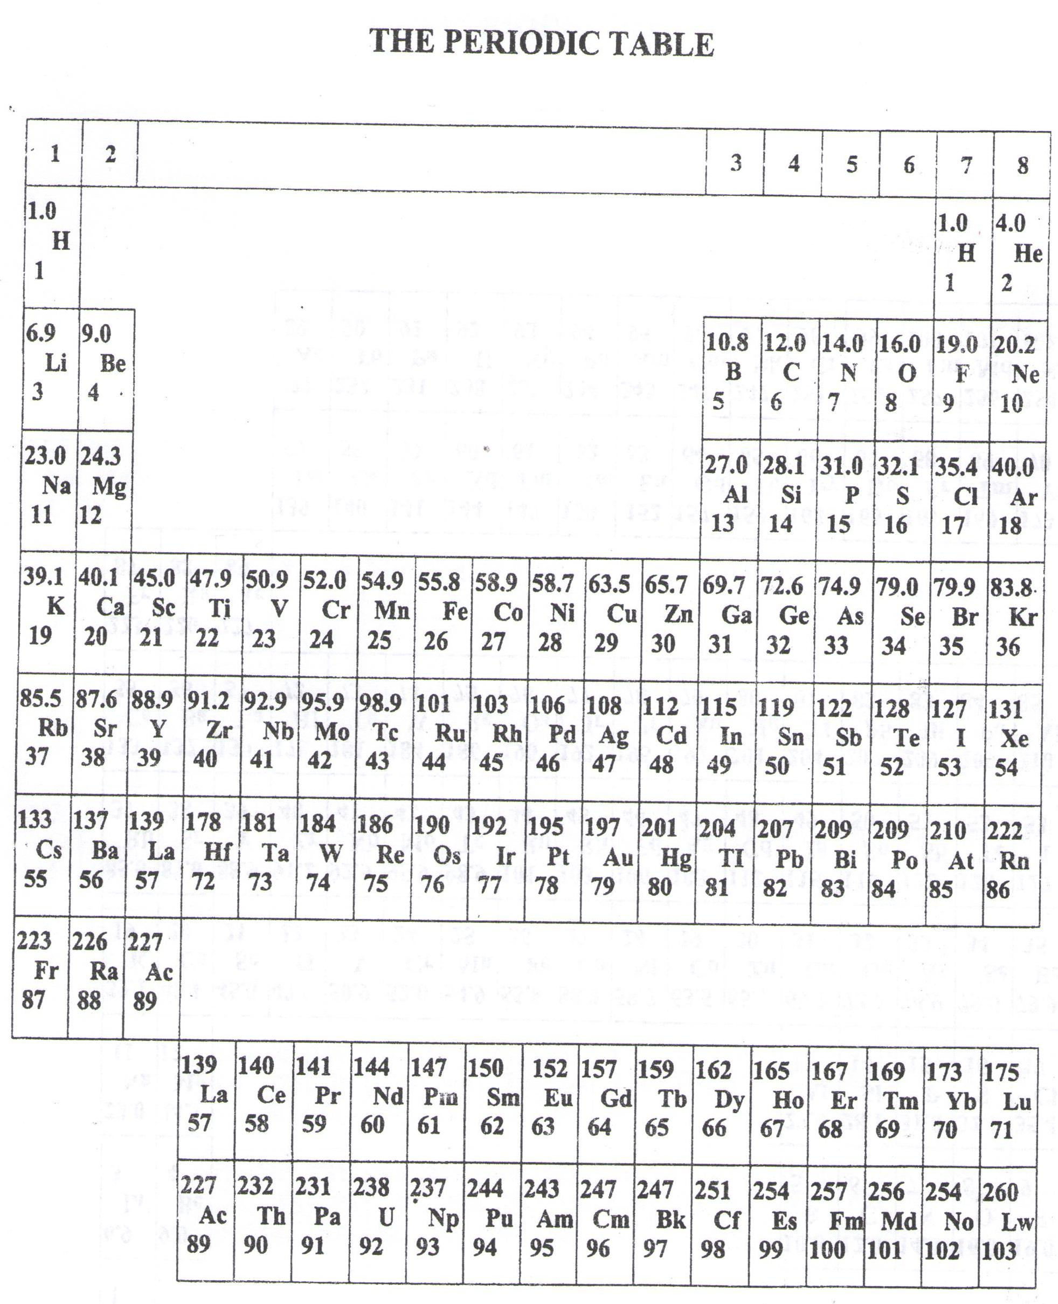

* ===END===

WELCOME TO SENIOR SIX, YEAR 2022

This is the last page of the printed paper, Page 19